Winter Head Wraps for Warmth and Style
By Rachel Tallis
One of this season’s biggest trends has been winter head wraps. Not only are they extremely stylish, but they also help keep ears warm on those crisp walks to class. After such a long winter, it’s nice to find a cute way to stay warm. Luckily, there are several different styles of winter head wraps for everyone’s unique taste. These are perfect for those days when hat hair is not wanted. Here are a few options all under $10!
Knit: Knit head wraps are the most common and are extremely useful for those days that are absolutely freezing. They fit closely to the ears for extra warmth. For a different look, try head wraps that are knit or crocheted with different patterns. Check out this simple yet fashionable knit head wrap from Tilly’s for just $5.98!
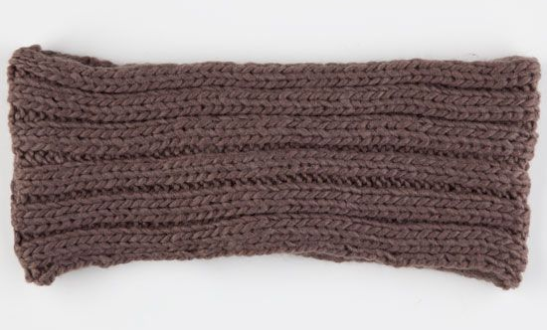
http://www.tillys.com/tillys/variants.aspx?prod=223632400&ctlg=020_Girls&cid=1301&source=1&size=
Knot: For a variation on the classic knit, try a knotted head wrap. Simple, yet unique, this style can be worn dressed up or down and is very warm. This is definitely the most common style, for a good reason! Check this one out for just $3.80 from Forever 21.
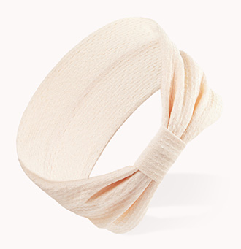
http://www.forever21.com/Product/Product.aspx?BR=f21&Category=acc_hair-headwraps&ProductID=1000108180&VariantID=

Decorated: For those who like to play around with their look and aren’t afraid of color, decorated head wraps are fun to try. Whether a large knit flower is added, or it has been bedazzled with jewels, decorated head wraps are a great way to add some life to a dreary day. Take a look at this thick crocheted head wrap with flower from Etsy for only $4.99. 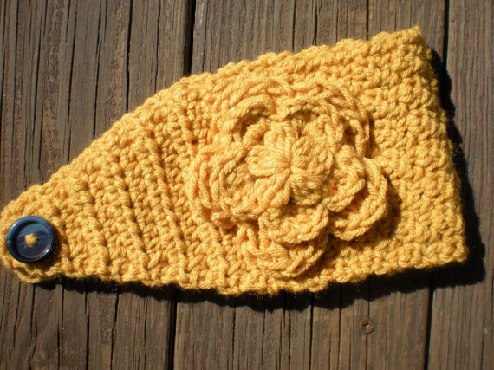
http://www.etsy.com/listing/111877406/pattern-flower-band-easy-crochet-p-d-f?ref=sr_gallery_26&ga_search_query=winter+head+wrap&ga_order=most_relevant&ga_ship_to=US&ga_min=0&ga_max=9.99&ga_page=3&ga_search_type=all&ga_view_type=gallery
It seems as though this winter is not quite over, so buy a cute head wrap for an affordable way to stay warm! Take advantage of these cute winter accessories, and use them on a chilly night even as the weather warms up. Being warm and stylish is always a win-win.

